AIA K-12 Lesson Guides
https://www.aia.org/pages/6319595-k-12-problem-based-lesson-guides
Activity Sheet
Holding on Through the Hurricane Activity Sheet >
Background
As a member of the Architectural Safety Assessment Program (ASAP), you have been deployed to the East Coast where powerful hurricanes have ravaged existing homes. Your task is to create a new housing development that is better prepared to withstand future hurricane activity. You will demonstrate your understanding of recommended building strategies and materials with the resilience to withstand a hurricane.
Problem
You are a member of the Architectural Safety Assessment Program team. You have been sent to the East Coast where there have been a series of devastating hurricanes in the past few years. Your team has been tasked with designing a housing development that is built to withstand future hurricanes by determining appropriate building strategies and materials. You will represent a model and verbal explanation to the City Council at its next meeting in three weeks. Be prepared!
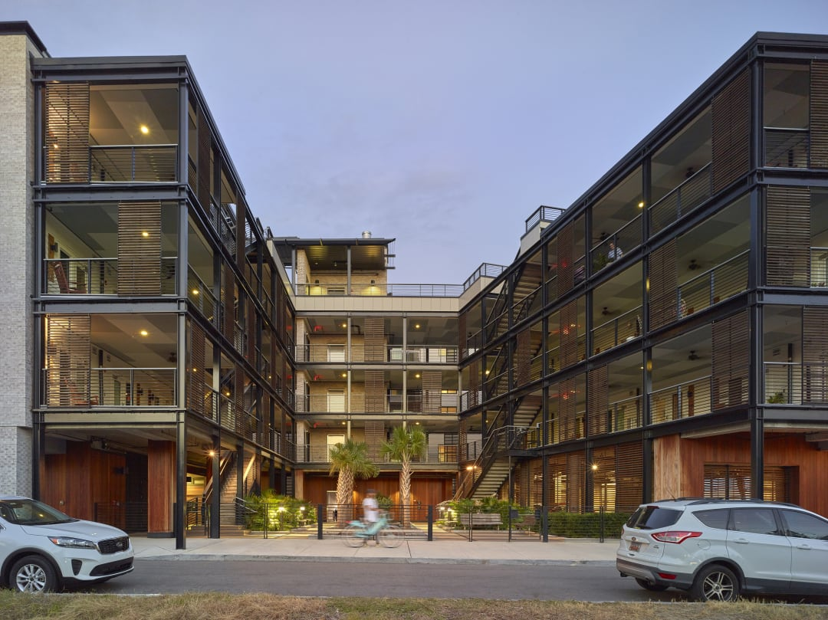
WILLIAMS TERRACE (LEARN MORE ABOUT THIS PROJECT IN THE LEARNING RESOURCES TAB)
Learning Resources
- Disaster Assistance Handbook >
- How building science and research can help avert disaster >
- Williams Terrace >
NOAA
- National Hurricane Center >
NASA
- Hurricanes and Tropical Storms >
Geophysical Fluid Dynamics Laboratory (GFDL)
- Global Warming and Hurricanes >
National Geographic
- The Anatomy of a Hurricane >
New Home Source
- How to Build a Hurricane-Resistant Home >
New York Times
- Among Ruins of Mexico Beach Stands One House, Built 'for the Big One'" >
Building Science Corporation
- Flood and Hurricane Resistant Buildings >
Hands-On
- Hurricane Simulation Activity >
- Hurricane House Challenge >
- Building for Hurricanes Design Challenge >
- Storm Surge Activity >
Video Resources
- AIA Film Challenge >

