AIA K-12 Lesson Guides
https://www.aia.org/pages/6319595-k-12-problem-based-lesson-guides
Activity Sheet
Fitting In Activity Sheet >
Background
The location of a new apartment building needs to be determined in order to retain the historical context of the city block as well as the views of the city skyline.
Problem
You are a city planner in charge of figuring out the best location for a new downtown apartment building.
The city block where the new structure will go is in the historical district of a major city. The mayor is worried about how the new building will look from all angles as you enter the city.
The restaurant owner next door is worried about how your building will complement hers. You will need to take their concerns into consideration when choosing the location, design, and shape of the building.
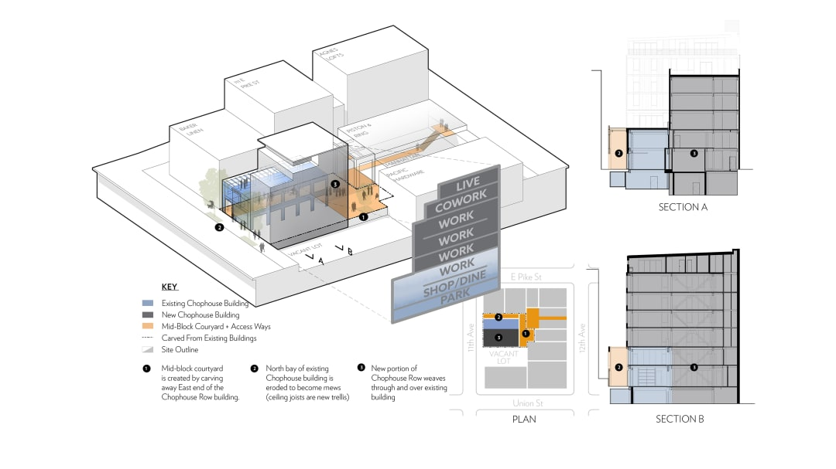
CHOPHOUSE ROW (LEARN MORE ABOUT THIS PROJECT IN THE LEARNING RESOURCES TAB)
Learning Resources
- Designing for Integration >
- Chophouse Row >
- Cowford Chophouse >
National Geographic
- Map Skills for Elementary Students >
Historical Downtown
- Williamsburg Aesthetics Statement >
- Sample Skyline Images >
Hands-On
- Online Mapping Activities >
- Mapping the Classroom >
- Analyze a Community Map >
Video Resources
- AIA Film Challenge >

