AIA K-12 Lesson Guides
https://www.aia.org/pages/6319595-k-12-problem-based-lesson-guides
Activity Sheet
Diminutive Dwellings Activity Sheet >
Background
As a recent college graduate, you are looking to purchase your first home. A decision must be made between remodeling a small cottage or designing a tiny house. You will demonstrate your understanding of design economy by creating efficient and flexible small spaces in your tiny home or remodeled cottage.
Problem
You are a recent college graduate preparing to buy your first home. As you begin exploring your options, you have come across two interesting choices:
- Your first option is to remodel a cottage that was built in 1957. The cottage is a 750-square-foot two-bedroom, one-bath home. While the bones of the house are good, it will need updates to use the smaller space more efficiently.
- Your second option is to build a tiny home. The trend has become popular in your town, and since you do not require a lot of space, it may be a viable option. With only 500 square feet to work with, you will need to design flexible spaces to make the tiny home functional.
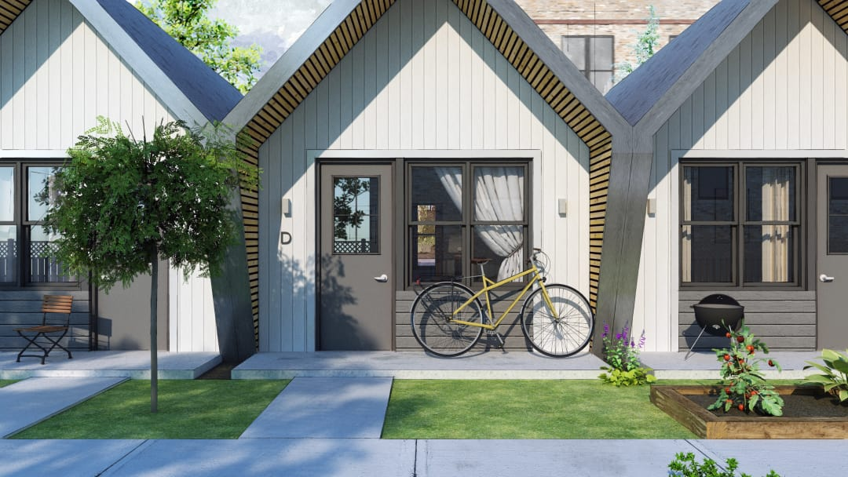
B.L.I.S.S. TINY HOMES TEAM (LEARN MORE ABOUT THE PROJECT IN THE LEARNING RESOURCES TAB)
Learning Resources
- Designing for Economy >
- B.L.I.S.S. Tiny Homes >
- Deane's House >
- Cully Grove (cottage) >
DSIRE
- Database of State Incentives for Renewables & Efficiency >
Tiny Home Resources
- Design Yours >
- 19 Tiny House Design Tips >
- 30 photos that show exactly how a tiny house is made >
- Tiny House Plans >
Cottage Resources
- Cottage Remodel >
- 19 Ways to Cut Costs on Your House Remodel >
- Model for Lowering a House's Energy Footprint >
- 5 Steps to Ensure Design Efficiency for Your Construction Project >
Hands-On
- Exploring Solar Power >
Video Resources
- AIA Film Challenge >

