AIA K-12 Lesson Guides
https://www.aia.org/pages/6319595-k-12-problem-based-lesson-guides
Activity Sheet
Net Zero Launch Activity Sheet >
Background
You are an architect who must prepare an action plan for a local federal building to meet the net zero goals outlined in Section 433 of the Energy Independence and Security Act (EISA). You will explore concepts related to sustainability, resiliency, energy, and materials. You will demonstrate your understanding of what methods, strategies, and materials can move a building toward the net zero energy goals.
Problem
You are an architect. The principals in your firm have asked you to review the Energy Independence and Security Act (EISA), Section 433; find a non-compliant federal building in your state that will need to be updated with energy efficient materials; and create a plan of action for the building managers to implement the necessary changes to achieve zero net energy. You will need to learn all you can about Section 433 of the EISA and what methods and strategies are available to update older federal buildings to achieve the net zero goal. The partners at your firm have given you three weeks to submit your plan of action.
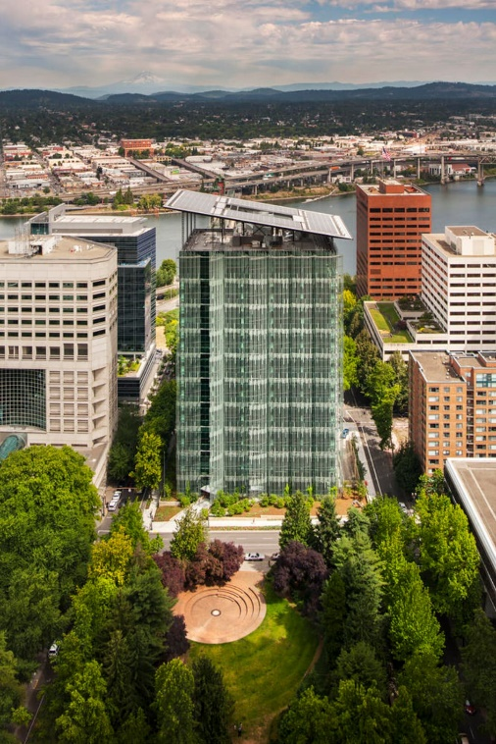
THE EDITH GREEN-WENDELL WYATT FEDERAL BUILDING (LEARN MORE ABOUT THIS PROJECT IN THE LEARNING RESOURCES TAB)
Learning Resources
- Sustainability >
- To lead with climate action, architects can start by reducing emissions >
- The Edith Green - Wendell Wyatt Federal Building >
- Designing for Energy >
- Design for Change >
- Designing for Resources >
US Congress
- The Energy Independence and Security Act of 2007 >
Zero Energy Project
- Extremely Energy Efficient Homes >
Energy.gov
- Net Zero Energy, Water, and Waste Handbooks >
Sustainable Facilities Tool
- Net Energy >
Hands-On
- Solar Power Activity >
- Passive Solar Design Activity >
- Energy Efficient Lighting System Design Activity >
Video Resources
- AIA Film Challenge >

