AIA K-12 Lesson Guides
https://www.aia.org/pages/6319595-k-12-problem-based-lesson-guides
Activity Sheet
Hot in Here Activity Sheet >
Background
The sunlight coming through the large picture windows in your classroom is heating the room and making the you uncomfortable. You will explore envelope design, shade structures, and solar energy.
Problem
Your teacher has just created a new seating chart and your desk is next to two large windows. You've noticed that on sunny afternoons your section of the classroom gets really hot. Your teach won't assign a new seating chart, so you will need to devise a solution to protect your section of the classroom!
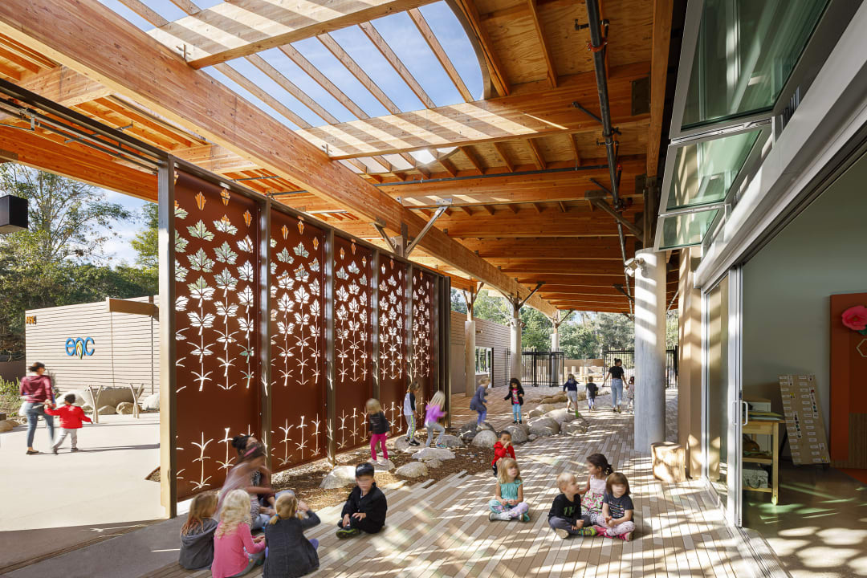
ENVIRONMENTAL NATURE CENTER AND PRESCHOOL (LEARN MORE ABOUT THIS PROJECT IN THE LEARNING RESOURCE TAB)
Learning Resources
- Building Science and Technology: Better Envelope >
- Environmental Nature Center and Preschool >
Better Lesson
- A Place in the Shade >
Science A-Z
- Light >
Teach Engineering
- Let the Sun Shine! >
Hands-On
- Sun or Shade? >
- Made for the Shade >
Video Resources
- AIA Film Challenge >

